Marketing Research

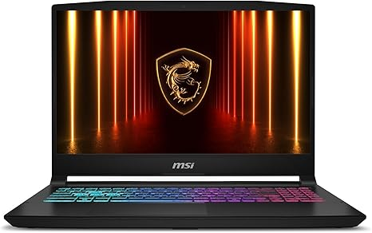

MSI Katana 15 HX 15.6” 165Hz QHD+ Gaming Laptop: Intel Core i9-14900HX, NVIDIA Geforce RTX 5070, 32GB DDR5, 1TB NVMe SSD, RGB Keyboard, Win 11 Home: Black (B14WGK-016US)

LKR 499,126.29
4.1 4.1 out of 5 stars (314)

Item Details
Brand | msi
Model Name | Katana 15 HX B14WGK-016US
Screen Size | 15.6 Inches
Color | Black
Hard Disk Size | 1 TB
CPU Model | Core i9
Ram Memory Installed Size | 32 GB
Operating System | Windows 11 Home
Special Feature | Backlit Keyboard, HD Audio
Graphics Card Description | RTX 5070

About this item

- Intel Core i9 HX Power for Elite Gaming: Dominate demanding titles with the Intel Core i9-14900HX and its 24-core hybrid architecture, delivering fast load times, high FPS, and smooth multitasking.
- GeForce RTX 5070 With Ray Tracing & DLSS 4: Powered by NVIDIA Blackwell, the RTX 5070 delivers stronger ray tracing, higher FPS, faster AI upscaling, and more responsive gameplay—ideal for competitive and cinematic gaming.
- QHD 165Hz, 100% DCI-P3 for Ultra-Clear Combat: The QHD 165Hz display reveals more detail, reduces motion blur, and boosts visibility in fast-paced games while delivering richer, more accurate colors.
- Cooler Boost 5 for Sustained Performance: Dual fans and a 5-heat-pipe share-pipe design keep the CPU and GPU cool, maintaining stable frame rates during long gaming marathons.
- 4-Zone RGB Keyboard + Full Game-Ready Ports: Customize your setup with a 4-zone RGB keyboard and highlighted WASD keys. Includes USB-C Gen 2, HDMI up to 8K, multiple USB-A ports, RJ45, Wi-Fi 6E & Hi-Res Audio.

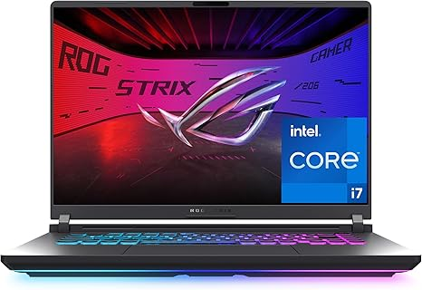

ASUS ROG Strix G16 (2025) Gaming Laptop, 16” FHD+ 16:10 165Hz/3ms Display, NVIDIA® GeForce RTX™ 5060 Laptop GPU, Intel® Core™ i7 Processor 14650HX, 16GB DDR5, 1TB Gen 4 SSD, Wi-Fi 7, Windows 11 Home
LKR444,206.68
4.5 4.5 out of 5 stars (457)

Item Details
Brand | ASUS
Model Name | ROG Strix G16
Screen Size | 16 Inches
Color | Eclipse Gray
Hard Disk Size | 1 TB
CPU Model | Core i7
Ram Memory Installed Size | 16 GB
Operating System | Windows 11 Home
Special Feature | ROG Nebula Display, Tri-Fan Technology
Graphics Card Description | Dedicated

About this item

- HIGH-LEVEL PERFORMANCE – Unleash power with Windows 11 Home, an Intel Core i7 Processor 14650HX, and an NVIDIA GeForce RTX 5060 Laptop GPU powered by the NVIDIA Blackwell architecture and featuring DLSS 4 and Max-Q technologies.
- FAST MEMORY AND STORAGE – Multitask seamlessly with 16GB of DDR5-5600MHz memory and store all your game library on 1TB of PCIe Gen 4 SSD.
- DYNAMIC DISPLAY AND SMOOTH VISUALS – Immerse yourself in stunning visuals with the smooth 165Hz FHD+ display for gaming, creation, and entertainment. Featuring a new ACR film that enhances contrast and reduces glare.
- STATE-OF-THE-ART ROG INTELLIGENT COOLING – ROG’s advanced thermals keep your system cool, quiet and comfortable. State of the art cooling equals best in class performance. Featuring an end-to-end vapor chamber, tri-fan technology and Conductonaut extreme liquid metal applied to the chipset delivers fast gameplay.
- FULL-SURROUND RGB LIGHTBAR, YOUR WAY – Showcase your style with a 360° RGB light bar that syncs with your keyboard and ROG peripherals. In professional settings, Stealth Mode turns off all lighting for a sleek, refined look.

https://www.amazon.com/ASUS-ROG-Strix-Gaming-Laptop/dp/B0DZZWMB2L/ref=sr_1_2?_encoding=UTF8&content-id=amzn1.sym.bd749ccd-05a5-46df-9094-58bcc6398482&dib=eyJ2IjoiMSJ9.RZ35XpHPkWk_GhtWtXkz8tF36VmIqrudAYb2LMFI_-nuJw7s_M3nxJYG08ZlEKVO_xtq-VJcoI0H4mLRkQKu6ZVslqzhUj9bVYm1Q6gmtgwtOaZYxa-ifKOuGZM67rrdIkGLEZT8gx0tf83HQUOAfcE6iOTLlrCYHXiWgGcnxy-RbVMqkbD1RNkl9HhbuqKA47j9W_d897g5UJoI8K0zLhZuVJHBc9sta_JpL-HzeLvYuxcp0VKRxWpDGUPv6GfEun2iB8vK9AKDc-8vGTKaMq15Lk4e753J7Vo4KFH4Omc.eFp8YFFb-UIuWXek4nSwL_AamqiHOpkQbr1xR15KSAc&dib_tag=se&keywords=gaming&pd_rd_r=906c91dc-870d-484b-a4d2-8c6704b3c21f&pd_rd_w=Nrx7a&pd_rd_wg=MzV3s&qid=1780381372&sr=8-2&th=1

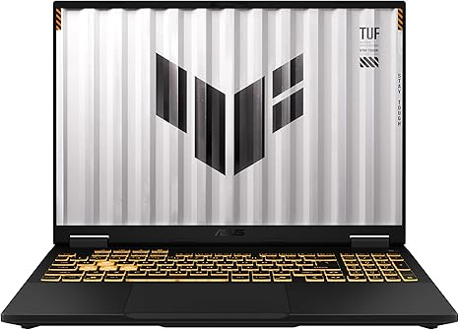

ASUS TUF Gaming F16 (2025) Gaming Laptop, 16” FHD+ 165Hz 16:10 Display, Intel® Core™ i5 Processor 13450HX, NVIDIA® GeForce RTX™ 5050, 16GB DDR5, 512GB PCIe Gen4 SSD, Wi-Fi 6E, Win 11 Home

LKR348,071.68
4.4 4.4 out of 5 stars (53)

Item Details
Brand | ASUS
Model Name | TUF Gaming A16
Screen Size | 16 Inches
Color | Jaeger Gray
Hard Disk Size | 512 TB
CPU Model | Core i5
Ram Memory Installed Size | 16 GB
Operating System | Windows 11 Home
Graphics Card Description | Dedicated
CPU Speed | 4.6 GHz

About this item

- READY FOR ANYTHING – Dive headfirst into gaming on Windows 11 powered by the Intel Core i5 Processor 13450HX and an NVIDIA GeForce RTX 5050 Laptop GPU with a Max TGP of 115W and NVIDIA Advanced Optimus.
- SUBTLE STYLING – The TUF Gaming F16 maintains its classic design, boasting a subtle embossed TUF logo on its sleek cover.
- IMMERSIVE VISUALS – The TUF Gaming F16’s FHD+ 165Hz display with 100% sRGB color draws you into the action. Adaptive-Sync technology reduces lag, minimizes stuttering, and eliminates visual tearing for ultra-smooth gameplay.
- MILITARY GRADE DURABILITY – As a TUF gaming machine, the F16 has been rigorously tested to meet Military Grade testing standards, MIL-STD-810H. Rest easy knowing this laptop will operate at peak performance in harsh conditions.
- EFFICIENT COOLING – Equipped with 2nd Gen Arc Flow Fans, full-width heatsink, and full-width vent, the TUF Gaming F16 optimizes cooling performance without extra noise.

https://www.amazon.com/ASUS-TUF-Gaming-Laptop-165Hz/dp/B0FFDDFW47/ref=sr_1_7?_encoding=UTF8&content-id=amzn1.sym.bd749ccd-05a5-46df-9094-58bcc6398482&dib=eyJ2IjoiMSJ9.RZ35XpHPkWk_GhtWtXkz8tF36VmIqrudAYb2LMFI_-nuJw7s_M3nxJYG08ZlEKVO_xtq-VJcoI0H4mLRkQKu6ZVslqzhUj9bVYm1Q6gmtgwtOaZYxa-ifKOuGZM67rrdIkGLEZT8gx0tf83HQUOAfcE6iOTLlrCYHXiWgGcnxy-RbVMqkbD1RNkl9HhbuqKA47j9W_d897g5UJoI8K0zLhZuVJHBc9sta_JpL-HzeLvYuxcp0VKRxWpDGUPv6GfEun2iB8vK9AKDc-8vGTKaMq15Lk4e753J7Vo4KFH4Omc.eFp8YFFb-UIuWXek4nSwL_AamqiHOpkQbr1xR15KSAc&dib_tag=se&keywords=gaming&pd_rd_r=906c91dc-870d-484b-a4d2-8c6704b3c21f&pd_rd_w=Nrx7a&pd_rd_wg=MzV3s&qid=1780381372&sr=8-7&th=1

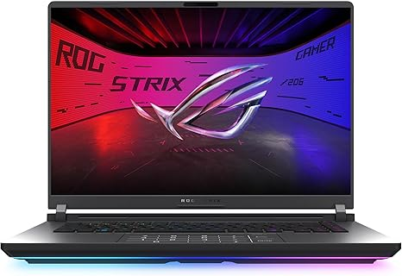

ASUS ROG Strix G16 (2025) Gaming Laptop, 16” ROG Nebula Display 16:10 2.5K 240Hz/3ms, NVIDIA® GeForce RTX™ 5070 Ti GPU, Intel® Core™ Ultra 9 275HX Processor, 32GB DDR5, 1TB SSD, Wi-Fi 7, Win11 Home
LKR859,519.83
4.4 4.4 out of 5 stars (170)

Item Details
Brand | ASUS
Model Name | ROG Strix G16
Screen Size | 16 Inches
Color | Black
Hard Disk Size | 1000 GB
CPU Model | Intel Core Ultra 9
Ram Memory Installed Size | 32 GB
Operating System | Windows 11 Home
Special Feature | Backlit Keyboard
Graphics Card Description | Dedicated

About this item

- CUTTING-EDGE PERFORMANCE – Experience next-level performance with Windows 11 Home, an Intel Core Ultra 9 275HX Processor, and an NVIDIA GeForce RTX 5070 Ti Laptop GPU powered by the NVIDIA Blackwell architecture and featuring DLSS 4 and Max-Q technologies.
- HIGH-PERFORMANCE MEMORY AND STORAGE – Multitask seamlessly with 32GB of DDR5-5600MHz memory and store your game library on 1TB of PCIe Gen 4 SSD.
- PREMIUM ROG NEBULA DISPLAY – Immerse yourself in stunning visuals with the ultra-fast 240Hz/3ms display ideal for gaming, creation, and entertainment. Featuring a new ACR film that enhances contrast and reduces glare.
- STATE-OF-THE-ART ROG INTELLIGENT COOLING – ROG’s advanced thermals keep your system cool, quiet and comfortable. State of the art cooling equals best in class performance. Featuring an end-to-end vapor chamber, tri-fan technology and Conductonaut extreme liquid metal applied to the chipset delivers fast gameplay.
- CUSTOMIZABLE FULL-SURROUND RGB LIGHTBAR – Showcase your style with a full-surround RGB light bar that syncs with your keyboard and ROG peripherals. In professional settings, Stealth Mode turns off all lighting for a sleek, refined look.

https://www.amazon.com/ASUS-Gaming-Laptop-Nebula-Display/dp/B0DW1X5YCQ/ref=sr_1_14?_encoding=UTF8&content-id=amzn1.sym.bd749ccd-05a5-46df-9094-58bcc6398482&dib=eyJ2IjoiMSJ9.RZ35XpHPkWk_GhtWtXkz8tF36VmIqrudAYb2LMFI_-nuJw7s_M3nxJYG08ZlEKVO_xtq-VJcoI0H4mLRkQKu6ZVslqzhUj9bVYm1Q6gmtgwtOaZYxa-ifKOuGZM67rrdIkGLEZT8gx0tf83HQUOAfcE6iOTLlrCYHXiWgGcnxy-RbVMqkbD1RNkl9HhbuqKA47j9W_d897g5UJoI8K0zLhZuVJHBc9sta_JpL-HzeLvYuxcp0VKRxWpDGUPv6GfEun2iB8vK9AKDc-8vGTKaMq15Lk4e753J7Vo4KFH4Omc.eFp8YFFb-UIuWXek4nSwL_AamqiHOpkQbr1xR15KSAc&dib_tag=se&keywords=gaming&pd_rd_r=906c91dc-870d-484b-a4d2-8c6704b3c21f&pd_rd_w=Nrx7a&pd_rd_wg=MzV3s&qid=1780381372&sr=8-14&th=1



ASUS ROG Strix G16 (2025) Gaming Laptop, 16” ROG Nebula 16:10 2.5K 240Hz/3ms, NVIDIA® GeForce RTX™ 5080, Intel® Core Ultra 9 275HX, 32GB DDR5, 1TB PCIe Gen 4 SSD, Wi-Fi 7, Windows 11 Home, G615LW-AS96
LKR961,346.68
4.1 4.1 out of 5 stars (90)

Item Details
Brand | ASUS
Model Name | ROG Strix G16
Screen Size | 16 Inches
Color | Eclipse Gray
Hard Disk Size | 1 TB
CPU Model | Intel Core Ultra 9
Ram Memory Installed Size | 32 GB
Operating System | Windows 11 Home
Special Feature | Backlit Keyboard
Graphics Card Description | Dedicated

About this item

- CUTTING-EDGE PERFORMANCE – Experience next-level performance with Windows 11 Home, an Intel Core Ultra 9 275HX Processor, and an NVIDIA GeForce RTX 5080 Laptop GPU powered by the NVIDIA Blackwell architecture and featuring DLSS 4 and Max-Q technologies.
- HIGH-PERFORMANCE MEMORY AND STORAGE – Multitask seamlessly with 32GB of DDR5-5600MHz memory and store all your game library on 1TB of PCIe Gen 4 SSD, with raw throughput up to 7,000MB/s.
- PREMIUM ROG NEBULA DISPLAY – Immerse yourself in stunning visuals with the ultra-fast 240Hz display for gaming, creation, and entertainment. Featuring a new ACR film that enhances contrast and reduces glare.
- STATE-OF-THE-ART ROG INTELLIGENT COOLING – ROG’s advanced thermals keep your system cool, quiet and comfortable. State of the art cooling equals best in class performance. Featuring an end-to-end vapor chamber, tri-fan technology and Conductonaut extreme liquid metal applied to the chipset delivers fast gameplay.
- CUSTOMIZABLE FULL-SURROUND RGB LIGHTBAR – Showcase your style with a full-surround RGB light bar that syncs with your keyboard and ROG peripherals. In professional settings, Stealth Mode turns off all lighting for a sleek, refined look.
https://www.amazon.com/ASUS-Strix-Gaming-Laptop-Nebula/dp/B0DW1FVPK8/ref=sr_1_15?_encoding=UTF8&content-id=amzn1.sym.bd749ccd-05a5-46df-9094-58bcc6398482&dib=eyJ2IjoiMSJ9.RZ35XpHPkWk_GhtWtXkz8tF36VmIqrudAYb2LMFI_-nuJw7s_M3nxJYG08ZlEKVO_xtq-VJcoI0H4mLRkQKu6ZVslqzhUj9bVYm1Q6gmtgwtOaZYxa-ifKOuGZM67rrdIkGLEZT8gx0tf83HQUOAfcE6iOTLlrCYHXiWgGcnxy-RbVMqkbD1RNkl9HhbuqKA47j9W_d897g5UJoI8K0zLhZuVJHBc9sta_JpL-HzeLvYuxcp0VKRxWpDGUPv6GfEun2iB8vK9AKDc-8vGTKaMq15Lk4e753J7Vo4KFH4Omc.eFp8YFFb-UIuWXek4nSwL_AamqiHOpkQbr1xR15KSAc&dib_tag=se&keywords=gaming&pd_rd_r=906c91dc-870d-484b-a4d2-8c6704b3c21f&pd_rd_w=Nrx7a&pd_rd_wg=MzV3s&qid=1780381372&sr=8-15&th=1

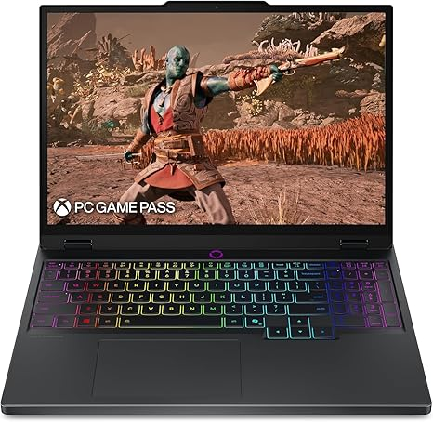

Lenovo Legion 5i – Gaming Laptop - Intel® Core™ i7-14700HX - 15" 2.5K WQXGA PureSight OLED Display–165Hz Refresh Rate–NVIDIA® GeForce RTX™ 5070 – 16 GB Memory – 1 TB Storage – 3 Months of PC GamePass

LKR602,010.63

4.4 4.4 out of 5 stars (73)
Item Details
Brand | Lenovo
Model Name | Legion 5i
Screen Size | 15.1 Inches
Color | Eclipse Black
Hard Disk Size | 1 TB
CPU Model | Core i7
Ram Memory Installed Size | 16 GB
Operating System | Windows 11 Home
Special Feature | Backlit Keyboard, HD Audio, Wifi
Graphics Card Description | Dedicated

About this item
- EXPLORE YOUR PASSION, ELEVATE YOUR GAME – The Lenovo Legion 5i empowers university gamers to explore their latest passions. With a thinner, lighter design and a Lenovo PureSight OLED display, it excels in gaming, streaming, and coursework on the go.
- GAME WITHOUT COMPROMISE – The Intel Core i7-14700HX processor features newly optimized hybrid architecture and industry leading technology that enables you to go beyond gaming and creation. With Intel, you can do it all.
- GAME CHANGER – Powered by NVIDIA Blackwell, the GeForce RTX 5070 graphics bring game-changing capabilities to gamers and creators. Equipped with incredible AI horsepower, prepare to unleash your creativity and experience next-level graphics fidelity.
- 3-MONTHS PC GAME PASS – Play hundreds of high-quality PC games with your new Lenovo Legion device and 3 months of PC Game Pass, including EA Play. With new games added all the time, there’s always something new to play.
- EXPERIENCE INTELLIGENT DESIGN –Lenovo AI Engine+ enhances FPS in today’s top AAA games while also reducing render times in today's premier creation apps. Easily managed through Legion Space, you can enjoy AI-tuned performance effortlessly.
- SMOOTH GAMEPLAY AND TRUE-TO-LIFE COLORS – Enjoy high-fidelity gaming, exact color accuracy, and extended battery life with the PureSight OLED display. Fast response times, flexible refresh rates, and AI-driven adjustments keep your visuals sharp and smooth.
- WHISPER QUIET GAMING – Legion Coldfront: Hyper, combines turbo-charged stealth fans to direct cool air over key components, while robust copper heat pipes and aluminum heat sinks keep your system cool and quiet.
- GAME, STREAM, AND CREATE ANYWHERE – The Legion 5i delivers exceptional mobility for students on the go. Power-efficient hardware extends battery life, while fast-charging technology boosts your battery from 0 to 70% in under 30 minutes via USB Type-C.

https://www.amazon.com/Lenovo-Legion-i7-14700HX-Display-165Hz-Rate-NVIDIA%C2%AE/dp/B0F6NRYPPG/ref=sr_1_18?_encoding=UTF8&content-id=amzn1.sym.bd749ccd-05a5-46df-9094-58bcc6398482&dib=eyJ2IjoiMSJ9.RZ35XpHPkWk_GhtWtXkz8tF36VmIqrudAYb2LMFI_-nuJw7s_M3nxJYG08ZlEKVO_xtq-VJcoI0H4mLRkQKu6ZVslqzhUj9bVYm1Q6gmtgwtOaZYxa-ifKOuGZM67rrdIkGLEZT8gx0tf83HQUOAfcE6iOTLlrCYHXiWgGcnxy-RbVMqkbD1RNkl9HhbuqKA47j9W_d897g5UJoI8K0zLhZuVJHBc9sta_JpL-HzeLvYuxcp0VKRxWpDGUPv6GfEun2iB8vK9AKDc-8vGTKaMq15Lk4e753J7Vo4KFH4Omc.eFp8YFFb-UIuWXek4nSwL_AamqiHOpkQbr1xR15KSAc&dib_tag=se&keywords=gaming&pd_rd_r=906c91dc-870d-484b-a4d2-8c6704b3c21f&pd_rd_w=Nrx7a&pd_rd_wg=MzV3s&qid=1780381372&sr=8-18&th=1

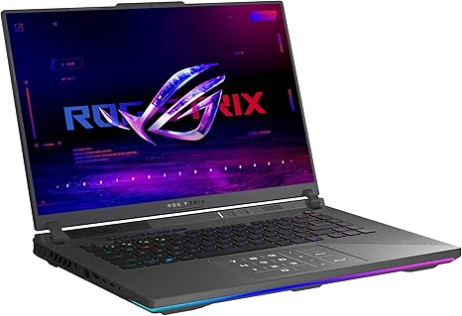

ASUS ROG Strix G16 (2025) Gaming Laptop, 16” ROG Nebula 16:10 2.5K 240Hz/3ms, NVIDIA® GeForce RTX™ 5070 Ti, AMD Ryzen™ 9 9955HX3D Processor, 32GB DDR5-5600, 1TB PCIe Gen 4 SSD, Wi-Fi 6E, Win 11 Home
LKR762,446.68
4.8 4.8 out of 5 stars (13)

Item Details
Brand | ASUS
Model Name | G614FR-DS96
Screen Size | 16 Inches
Color | Eclipse Gray
Hard Disk Size | 1 TB
CPU Model | Ryzen 9
Ram Memory Installed Size | 32 GB
Operating System | Windows 11 Home
Special Feature | Backlit Keyboard
Graphics Card Description | Dedicated

About this item

- CUTTING-EDGE PERFORMANCE – Experience next-level performance with Windows 11 Home, an AMD Ryzen 9 9955HX3D Processor, and an NVIDIA GeForce RTX 5070 Ti Laptop GPU powered by the NVIDIA Blackwell architecture and featuring DLSS 4 and Max-Q technologies.
- HIGH-PERFORMANCE MEMORY AND STORAGE – Multitask seamlessly with 32GB of DDR5-5600MHz memory and store your game library on 1TB of PCIe Gen 4 SSD.
- PREMIUM ROG NEBULA DISPLAY – Immerse yourself in stunning visuals with the ROG Nebula Display, the ultra-fast 240Hz/3ms display for gaming, content creation, and entertainment. Featuring a new ACR film that enhances contrast and reduces glare.
- STATE-OF-THE-ART ROG INTELLIGENT COOLING – ROG’s advanced thermals keep your system cool, quiet and comfortable. State of the art cooling equals best in class performance. Featuring tri-fan technology and Conductonaut extreme liquid metal, it delivers fast gameplay.
- CUSTOMIZABLE RGB LIGHTBAR – Showcase your style with a customizable RGB light bar that syncs with your keyboard and ROG peripherals. In professional settings, Stealth Mode turns off all lighting for a sleek, refined look.
- MUX SWITCH WITH ADVANCED OPTIMUS – A MUX Switch boosts gaming performance by 5-10% by routing frames directly from the dGPU. Advanced Optimus improves battery life by automatically switching between the iGPU and dGPU based on the task, without restarting.
- 3-MONTH PC GAME PASS INCLUDED – Enjoy a free 3-month pass and access over 100 high-quality games. With new games added regularly, there’s always something new to play.

https://www.amazon.com/ASUS-Strix-Gaming-Laptop-Nebula/dp/B0DW1SVMZZ/ref=sr_1_43?_encoding=UTF8&content-id=amzn1.sym.bd749ccd-05a5-46df-9094-58bcc6398482&dib=eyJ2IjoiMSJ9.RZ35XpHPkWk_GhtWtXkz8tF36VmIqrudAYb2LMFI_-nuJw7s_M3nxJYG08ZlEKVO_xtq-VJcoI0H4mLRkQKu6ZVslqzhUj9bVYm1Q6gmtgwtOaZYxa-ifKOuGZM67rrdIkGLEZT8gx0tf83HQUOAfcE6iOTLlrCYHXiWgGcnxy-RbVMqkbD1RNkl9HhbuqKA47j9W_d897g5UJoI8K0zLhZuVJHBc9sta_JpL-HzeLvYuxcp0VKRxWpDGUPv6GfEun2iB8vK9AKDc-8vGTKaMq15Lk4e753J7Vo4KFH4Omc.eFp8YFFb-UIuWXek4nSwL_AamqiHOpkQbr1xR15KSAc&dib_tag=se&keywords=gaming&pd_rd_r=906c91dc-870d-484b-a4d2-8c6704b3c21f&pd_rd_w=Nrx7a&pd_rd_wg=MzV3s&qid=1780381372&sr=8-43&th=1

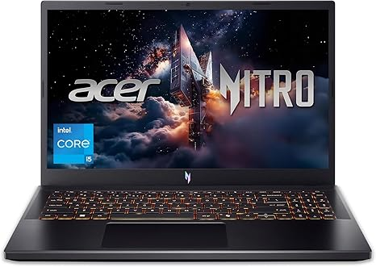

acer Nitro V Gaming Laptop | Intel Core i5-13420H Processor | NVIDIA GeForce RTX 4050 Laptop GPU | 15.6" FHD IPS 165Hz Display | 8GB DDR5 | 512GB Gen 4 SSD | Wi-Fi 6 | Backlit KB | ANV15-52-586Z

LKR265,196.68

4.5 4.5 out of 5 stars (332)

Item Details
Brand | Acer
Model Name | Nitro V
Screen Size | 15.6 Inches
Color | Black
Hard Disk Size | 512 GB
CPU Model | Core i5
Ram Memory Installed Size | 8 GB
Operating System | Windows 11 Home
Special Feature | Backlit Keyboard, Numeric Keypad
Graphics Card Description | Dedicated

About this item

- Beyond Performance: The Intel Core i5-13420H processor goes beyond performance to let your PC do even more at once. With a first-of-its-kind design, you get the performance you need to play, record and stream games with high FPS and effortlessly switch to heavy multitasking workloads like video, music and photo editing.
- AI-Powered Graphics: The state-of-the-art GeForce RTX 4050 graphics (194 AI TOPS) provide stunning visuals and exceptional performance. DLSS 3.5 enhances ray tracing quality using AI, elevating your gaming experience with increased beauty, immersion, and realism.
- Visual Excellence: See your digital conquests unfold in vibrant Full HD on a 15.6" screen, perfectly timed at a quick 165Hz refresh rate and a wide 16:9 aspect ratio providing 82.64% screen-to-body ratio. Now you can land those reflexive shots with pinpoint accuracy and minimal ghosting. It's like having a portal to the gaming universe right on your lap.
- Internal Specifications: 8GB DDR5 Memory (2 DDR5 Slots Total, Maximum 32GB); 512GB PCIe Gen 4 SSD
- Stay Connected: Your gaming sanctuary is wherever you are. On the couch? Settle in with fast and stable Wi-Fi 6. Gaming cafe? Get an edge online with Killer Ethernet E2600 Gigabit Ethernet. No matter your location, Nitro V 15 ensures you're always in the driver's seat. With the powerful Thunderbolt 4 port, you have the trifecta of power charging and data transfer with bidirectional movement and video display in one interface.

https://www.amazon.com/i5-13420H-Processor-GeForce-Display-ANV15-52-586Z/dp/B0F5KTGDS9/ref=sr_1_46?_encoding=UTF8&content-id=amzn1.sym.bd749ccd-05a5-46df-9094-58bcc6398482&dib=eyJ2IjoiMSJ9.RZ35XpHPkWk_GhtWtXkz8tF36VmIqrudAYb2LMFI_-nuJw7s_M3nxJYG08ZlEKVO_xtq-VJcoI0H4mLRkQKu6ZVslqzhUj9bVYm1Q6gmtgwtOaZYxa-ifKOuGZM67rrdIkGLEZT8gx0tf83HQUOAfcE6iOTLlrCYHXiWgGcnxy-RbVMqkbD1RNkl9HhbuqKA47j9W_d897g5UJoI8K0zLhZuVJHBc9sta_JpL-HzeLvYuxcp0VKRxWpDGUPv6GfEun2iB8vK9AKDc-8vGTKaMq15Lk4e753J7Vo4KFH4Omc.eFp8YFFb-UIuWXek4nSwL_AamqiHOpkQbr1xR15KSAc&dib_tag=se&keywords=gaming&pd_rd_r=906c91dc-870d-484b-a4d2-8c6704b3c21f&pd_rd_w=Nrx7a&pd_rd_wg=MzV3s&qid=1780381372&sr=8-46

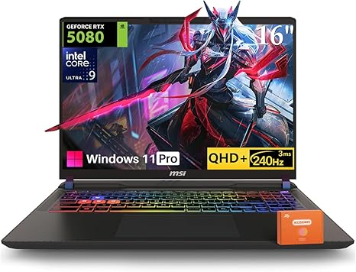

MSI Vector 16 HX AI Gaming Laptop, Intel Ultra 9 275HX(Up to 5.4GHz), NVIDIA RTX 5080 16GB GDDR7, 16" QHD+ 240Hz, Wi-Fi 7, 32 GB DDR5, 2 TB SSD, RGB Backlit Keyboard, Windows 11 Pro, w/Accessories

LKR1,077,043.68

Item Details
Brand | msi
Model Name | Vector 16 HX AI 400
Screen Size | 16 Inches
Color | Gray
Hard Disk Size | 2 TB
CPU Model | Intel Core Ultra 9
Ram Memory Installed Size | 32 GB
Operating System | Windows 11 Pro
Special Feature | 16" QHD+ 240Hz, Backlit Keyboard, Intel Ultra 9 Processor, NVIDIA RTX 5080, Wi-Fi 7
Graphics Card Description | Dedicated

About this item

- Unleash RTX 5080 Graphics Power in the MSI Vector: Experience elite gaming with the NVIDIA GeForce RTX 5080 16GB GDDR7 GPU on this gaming laptop 5080. Ray tracing and DLSS 4 deliver cinematic visuals and ultra-smooth frame rates in the most demanding AAA titles
- Ultra-Fast 240Hz QHD+ Display on MSI Gaming Laptop: Game and create with precision on a 16-inch 2560 x 1600 panel featuring a 240Hz refresh rate. High resolution meets high speed for immersive and competitive gameplay
- 24-Core Intel Ultra 9 in Gaming Laptop RTX 5080: Built for extreme multitasking and intensive applications, the Intel Ultra 9 275HX processor runs up to 5.4GHz and features 36MB L3 + 40MB L2 cache for powerhouse performance
- AI-Optimized MSI Laptop Efficiency: Harness the AI-enhanced capabilities of Intel’s integrated NPU to accelerate creative tasks, optimize workflows, and handle intelligent computing with ease
- Elite Connectivity & Expandability on MSI Vector: This gaming laptop RTX 5080 features dual Thunderbolt 5, HDMI 2.1, USB-A, Ethernet, SD card slot, and Wi-Fi 6E. Upgrade effortlessly with support for up to 64GB DDR5 RAM and 8TB SSD storage

https://www.amazon.com/Vector-Backlit-Keyboard-Windows-Accessories/dp/B0FWK2KV1Y/ref=sr_1_56?_encoding=UTF8&content-id=amzn1.sym.bd749ccd-05a5-46df-9094-58bcc6398482&dib=eyJ2IjoiMSJ9.RZ35XpHPkWk_GhtWtXkz8tF36VmIqrudAYb2LMFI_-nuJw7s_M3nxJYG08ZlEKVO_xtq-VJcoI0H4mLRkQKu6ZVslqzhUj9bVYm1Q6gmtgwtOaZYxa-ifKOuGZM67rrdIkGLEZT8gx0tf83HQUOAfcE6iOTLlrCYHXiWgGcnxy-RbVMqkbD1RNkl9HhbuqKA47j9W_d897g5UJoI8K0zLhZuVJHBc9sta_JpL-HzeLvYuxcp0VKRxWpDGUPv6GfEun2iB8vK9AKDc-8vGTKaMq15Lk4e753J7Vo4KFH4Omc.eFp8YFFb-UIuWXek4nSwL_AamqiHOpkQbr1xR15KSAc&dib_tag=se&keywords=gaming&pd_rd_r=906c91dc-870d-484b-a4d2-8c6704b3c21f&pd_rd_w=Nrx7a&pd_rd_wg=MzV3s&qid=1780381372&sr=8-56&th=1

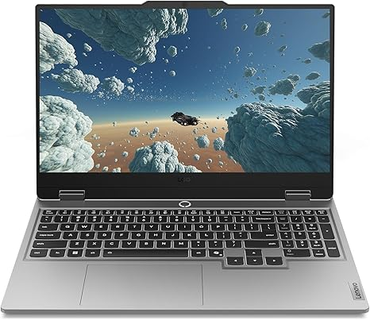

Lenovo Legion LOQ AI-Powered Gaming Laptop - Intel Core i7-13650HX, 15.6" FHD IPS 144Hz Display, GeForce RTX 5050, 16GB Memory, 1TB Storage, G-Sync, Luna Grey

LKR398,714.94

4.6 4.6 out of 5 stars (54)

Item Details
Brand | Lenovo
Model Name | LOQ
Screen Size | 15.6 Inches
Color | Luna Gray
Hard Disk Size | 1000 GB
CPU Model | Core i7
Ram Memory Installed Size | 16 GB
Operating System | Windows 11 Home
Special Feature | AI-Powered Gaming, Hyperchamber Cooling Technology, Lenovo AI Engine+, NVIDIA G-Sync
Graphics Card Description | Dedicated

About this item

- STEP UP TO TRUE GAMING – The Lenovo Legion LOQ is your first step into gaming, unlocking a new caliber of entertainment. Enjoy seamless AI experiences, high resolution and frame rates, with vacuum-sealed thermals to fast-track your performance.
- GAME WITHOUT COMPROMISE – Be everything you want to be, in game and out with optimized performance and new AI-enhanced features. Play harder and work smarter with the Intel Core i7-13650HX processor.
- STAY ICY, GAME SPICY – Lenovo LOQ’s Hyperchamber Cooling keeps your system from overheating with turbo fans and copper heat pipes. AI Engine+ ensures your laptop stays consistently cool while you bring the heat.
- KEYS THAT SLAY EVERY DAY – The Lenovo LOQ keyboard is built to vibe with a clean white backlight, full layout, and soft-landing switches for smooth, satisfying presses. Game, chat, flex—your way.
- GLOW UP YOUR VISUALS – The FHD IPS display is perfect for gaming and watching your favorite streams. NVIDIA G-Sync technology eliminates screen tearing, stuttering, and input lag, ensuring silky-smooth frame rates.
- GAME, WATCH, OPTIMIZE – Lenovo AI Engine+ makes gaming easy by optimizing your laptop’s performance automatically. It tunes your CPU, GPU, and system settings for smoother gameplay and better FPS.
- LOW-KEY LOOKS, HIGH-KEY DURABLE – The LOQ’s sleek aerospace-grade build keeps it lightweight but tough, with a durable aluminum cover made to handle whatever life throws at it.
- GAME, STREAM, AND CREATE ANYWHERE – The Lenovo LOQ is your ultimate on-the-go sidekick—light, backpack-ready, and always charged. Smart Battery Technology prevents battery drain, while Rapid Charge Pro powers you to 70% in under 30 minutes.

https://www.amazon.com/Lenovo-Legion-AI-Powered-Gaming-Laptop/dp/B0FY77GFRN/ref=sr_1_58?_encoding=UTF8&content-id=amzn1.sym.bd749ccd-05a5-46df-9094-58bcc6398482&dib=eyJ2IjoiMSJ9.RZ35XpHPkWk_GhtWtXkz8tF36VmIqrudAYb2LMFI_-nuJw7s_M3nxJYG08ZlEKVO_xtq-VJcoI0H4mLRkQKu6ZVslqzhUj9bVYm1Q6gmtgwtOaZYxa-ifKOuGZM67rrdIkGLEZT8gx0tf83HQUOAfcE6iOTLlrCYHXiWgGcnxy-RbVMqkbD1RNkl9HhbuqKA47j9W_d897g5UJoI8K0zLhZuVJHBc9sta_JpL-HzeLvYuxcp0VKRxWpDGUPv6GfEun2iB8vK9AKDc-8vGTKaMq15Lk4e753J7Vo4KFH4Omc.eFp8YFFb-UIuWXek4nSwL_AamqiHOpkQbr1xR15KSAc&dib_tag=se&keywords=gaming&pd_rd_r=906c91dc-870d-484b-a4d2-8c6704b3c21f&pd_rd_w=Nrx7a&pd_rd_wg=MzV3s&qid=1780381372&sr=8-58&th=1

